How To: “Recost Board”

| November-20 |

**Document Overview**

**Documentation Goals**

This documentation is intended to provide instruction for ***Using the “Recost Board” button in the Purchase Order system****.*

**Documentation Disclaimers**

* This document provides the specific location of the button so that the user can easily find it.
* Provides instructions for using the ***“Recost Board”*** button to help verify the most efficient cost of materials for a specific Purchase Order.
* Provides additional information for how to manually compare material quantities vs. material costs apart from using the ***“Recost Board”*** button.

**Table of Contents**

**Overview** 2

Location 2

Operation 3

# **Overview**

## Location

The ***“Recost Board”*** button is located in the following Menu Path: Purchasing -> Update/Enter Purchase Orders -> Enter/Edit PO’s. Alternatively, the user can quickly get to this screen using the Hot Key combination: ***[“P” – “U” – “1”]***.

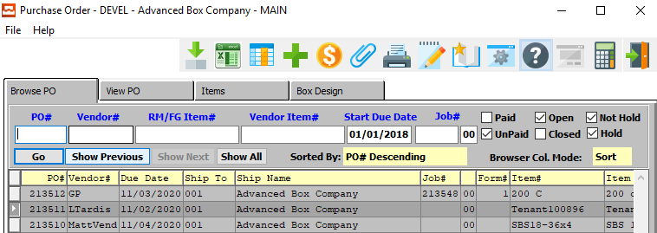

The user should then choose their desired Purchase Order from the *Browse PO* list, and navigate to the *Items* tab. The ***“Recost Board”*** button will be located at the bottom of this screen.

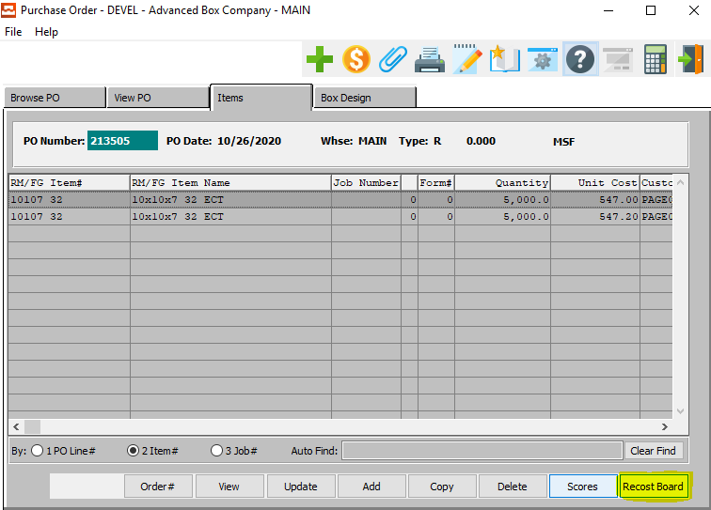

## Operation

The ***“Recalc Board”*** button is an optional recalculation that becomes an available option when multiple line items on a Purchase Order for the same or different jobs have the exact same information regarding the following fields:

|  |  |  |  |
| --- | --- | --- | --- |
| Board Grade | Roll Width | Sheet Length | Test |
| Flute | Score Allowances | Sheet Width |  |

Using this button will provide the user with the following information:

|  |  |  |  |
| --- | --- | --- | --- |
| A *Grand Total* of MSF | Lineal Footage | Tons | Weight |

In summary, the cost of each line item on the Purchase Order may be looking at a higher cost.

When calculating the grand total of all identical Purchase Order lines, the program may find a lower cost on the ***“M”-“F”*** *Vend Cost Matrix*. If the cost is lower than the current Purchase Order Cost on each Line Item, the program will prompt the user with an option to *Update* the current cost.

Please Note: the ***“M”-“F”-“1”*** screen houses *Folding Carton Materials*, and the ***“M”-“F”-“2”*** screen houses *Corrugated/Foam Materials.*

In the example below, notice that the cost is $80 per MSF on each line item and the program finds that the cost should be $55 for the grand total of 31.44 MSF. If the user clicks the “***Yes”*** button, the program will transfer the $55 to every line item that matches.

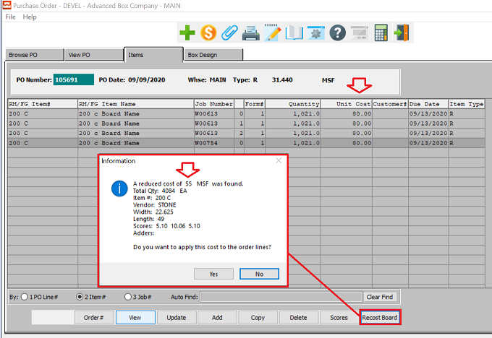

Reports such as the ***“P”-“R”-“4”*** *Material Required for Job* will sort materials by jobs with matching board code, size, and scoring.

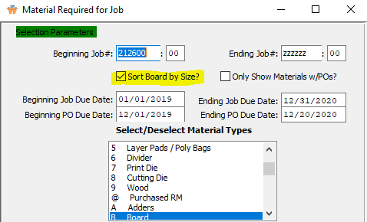

As you can see in the report example below, multiple jobs have the exact same board grade, sheet width, sheet length, and scoring allowances.

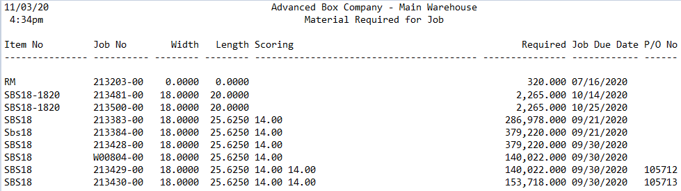

However, if the items were ordered on the exact same purchase order, the costs from either the ***“M”-“F”-“1”*** or the ***“M”-“F”-“2”*** *Cost Matrixes* may have imported the cost for only a single Job Quantity, rather than the total quantity for all jobs*.* This *Total Quantity* is what may bring your costs down, as defined within the *Cost Matrixes*.

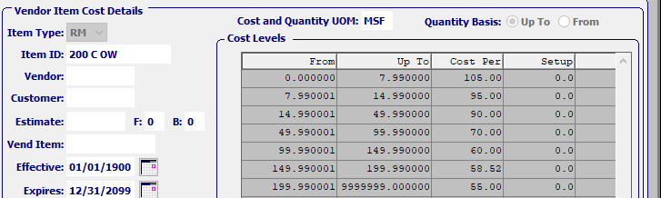

Please Note: The ***“Recalc Board*** calculation will not work if the jobs are listed on multiple different Purchase Orders, as it can only calculate the single Purchase Order on which the button is located.